**Institute For Individual Liberty**

The non-governmental organization Institute for Individual Liberty (IFIL) was established in January 2022 to advocate for issues related to classical liberalism, the free market, and individual responsibility.

We are an NGO composed of young, progressive, and talented people who share a passion and concern for the development and progression of Georgia’s future. IFIL members are united by common principles of non-aggression, the supremacy of the individual, property rights, free markets, and voluntary association, as well as freedom of speech and expression.

IFIL advocates and encourages minimal government interference in people's financial and private lives. Future activities associated with IFIL will be based on the unconditional belief that our bodies belong solely to ourselves; any use of force other than self-defense is immoral, and private property is "sacred."

The Institute for Individual Liberty uses an interactive, grassroots approach to offer an open platform for individuals (including ex-patriots residing in Georgia) to connect and express ideas and concerns with other organizations, civil society actors, governmental parties, and the private sector with the goal of having their voices heard and having an influence on individual and social liberty.

The Institute for Personal Freedom is a newly established organization.

However, in a short period of time, we have conducted informative pieces of training and held four leadership camps for more than 100 people from all over Georgia.

**Liberty Weekend, Surami**

We organized a four-day leadership camp outside of the capital city. The camp was focused on

teaching participants about concepts such as individual liberty, the rule of law, free trade

and comparing different political ideologies. Camp activities included lectures from

politicians and experts, as well as group competitions, intellectual challenges and a

traditional Georgian BBQ around a bonfire.

**Invited Speakers and topics of the camp:**

Zurab Girchi Japaridze - Leader and chairman of Girchi More Freedom - **“Political Ideologies”**

Tsotne Koberidze - Tbilisi City Council Member - **“How to Become a Politician in Georgia”**

Badri Grigalashvili - Politician of Girchi More Freedom - **“Judiciary System in Georgia”**

Zviad Khorguashvili - Financier, Lecturer - **“Economic Perspectives”**

Christopher Lingle - Professor of Economics, Free Trade Missionary - **“Free Trade”**

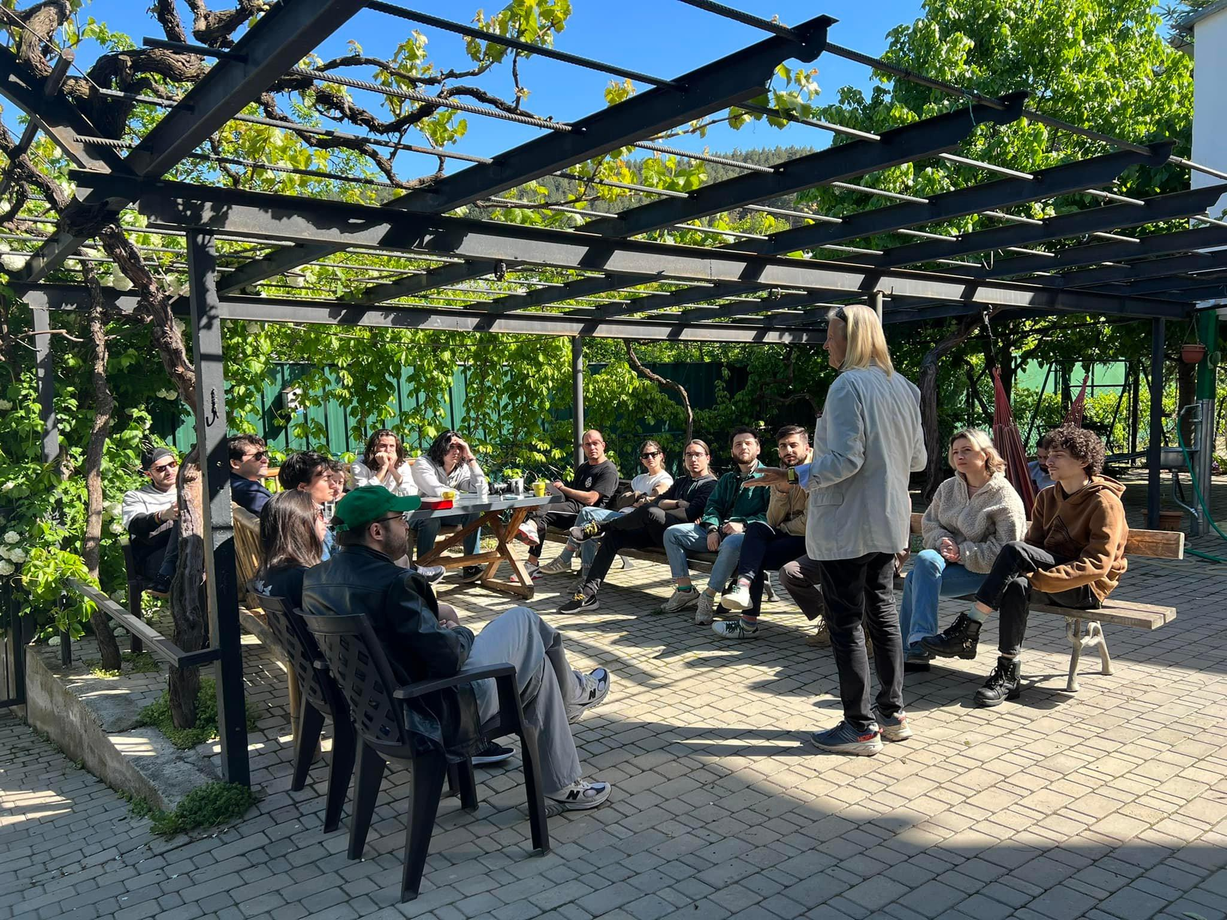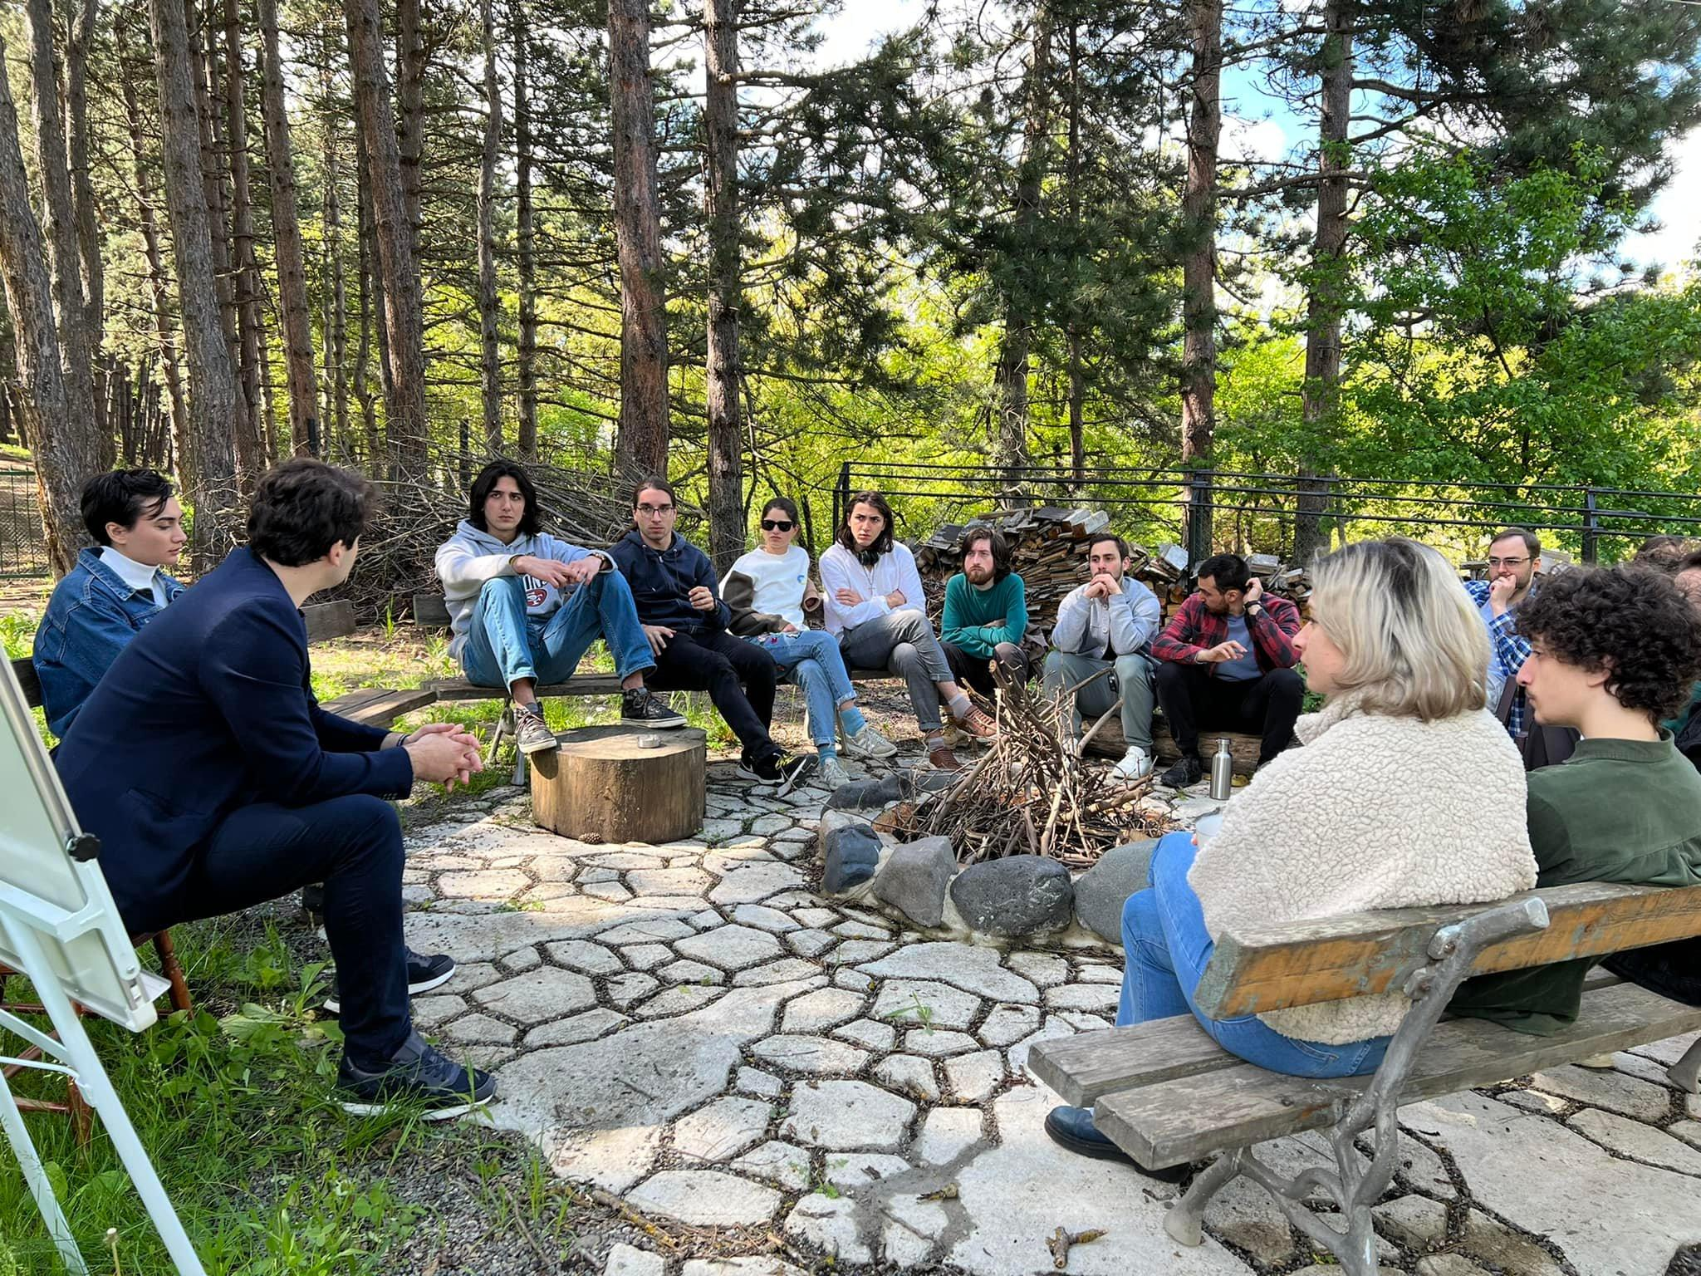

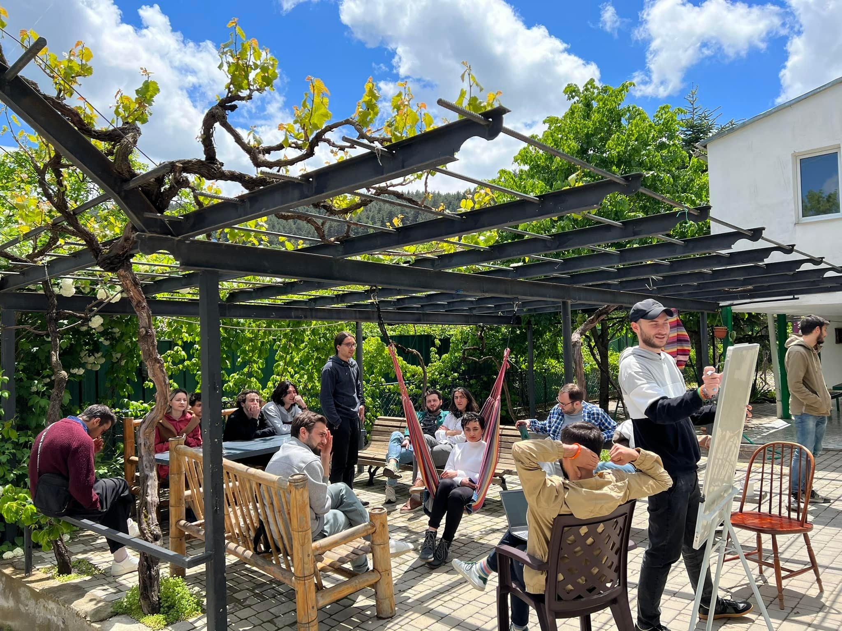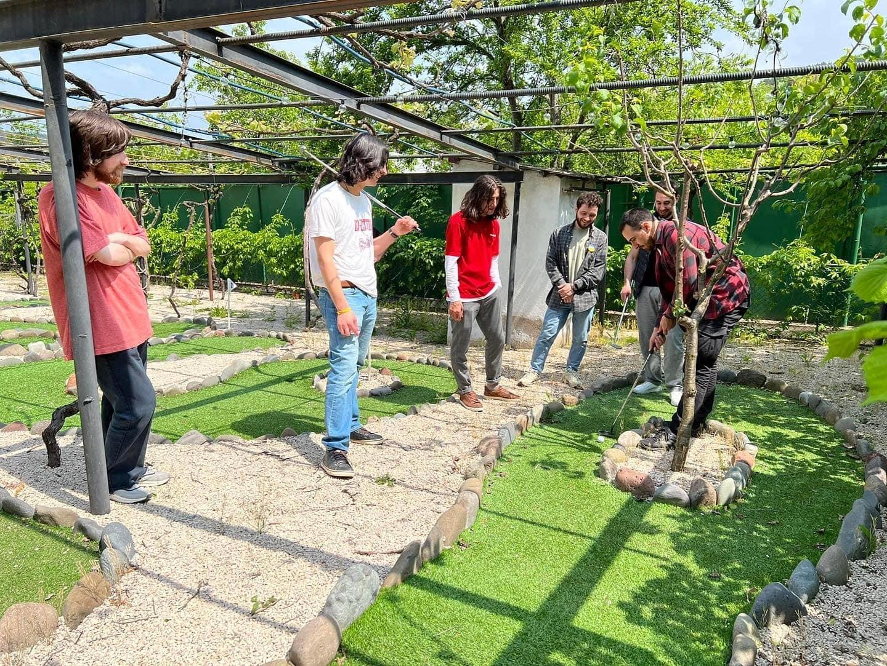

**Video**: <https://www.facebook.com/IFILiberty/videos/1710513785966517>

**Liberty Weekend, Borjomi**

Following the resounding success of our first Liberty Weekend, we have decided to further expand our partnership with VVD International (which also committed to collaborating in 2023) and invite more participants, speakers, and experts to share their views and philosophies with the next generations of Georgian leaders. Our second Liberty weekend culminated in a tour of a state-of-the-art Coca-Cola bottling plant in Georgia.

**Invited Speakers and topics of the Camp:**

Zaza BIbilashvili - Founder of Chavchavadze Center - **“Identity and Memory”**

Zurab Girchi Japaridze - Leader/Chairman of Girchi More Freedom - **“Political Ideologies”**

Ana Chikovani - Politician of Girchi More Freedom - **“The role of Ilia Chavchavadze in Georgian Liberalism”**

Dato Rogava - Founder of Ayn Rand Center Georgia - **“Ayn Rand Philosophy “**

Vasil Zhizhiashvili - Constitutional Lawyer at Association of Young Lawyers of Georgia - **“What needs to be changed in Georgian Judiciary System”**

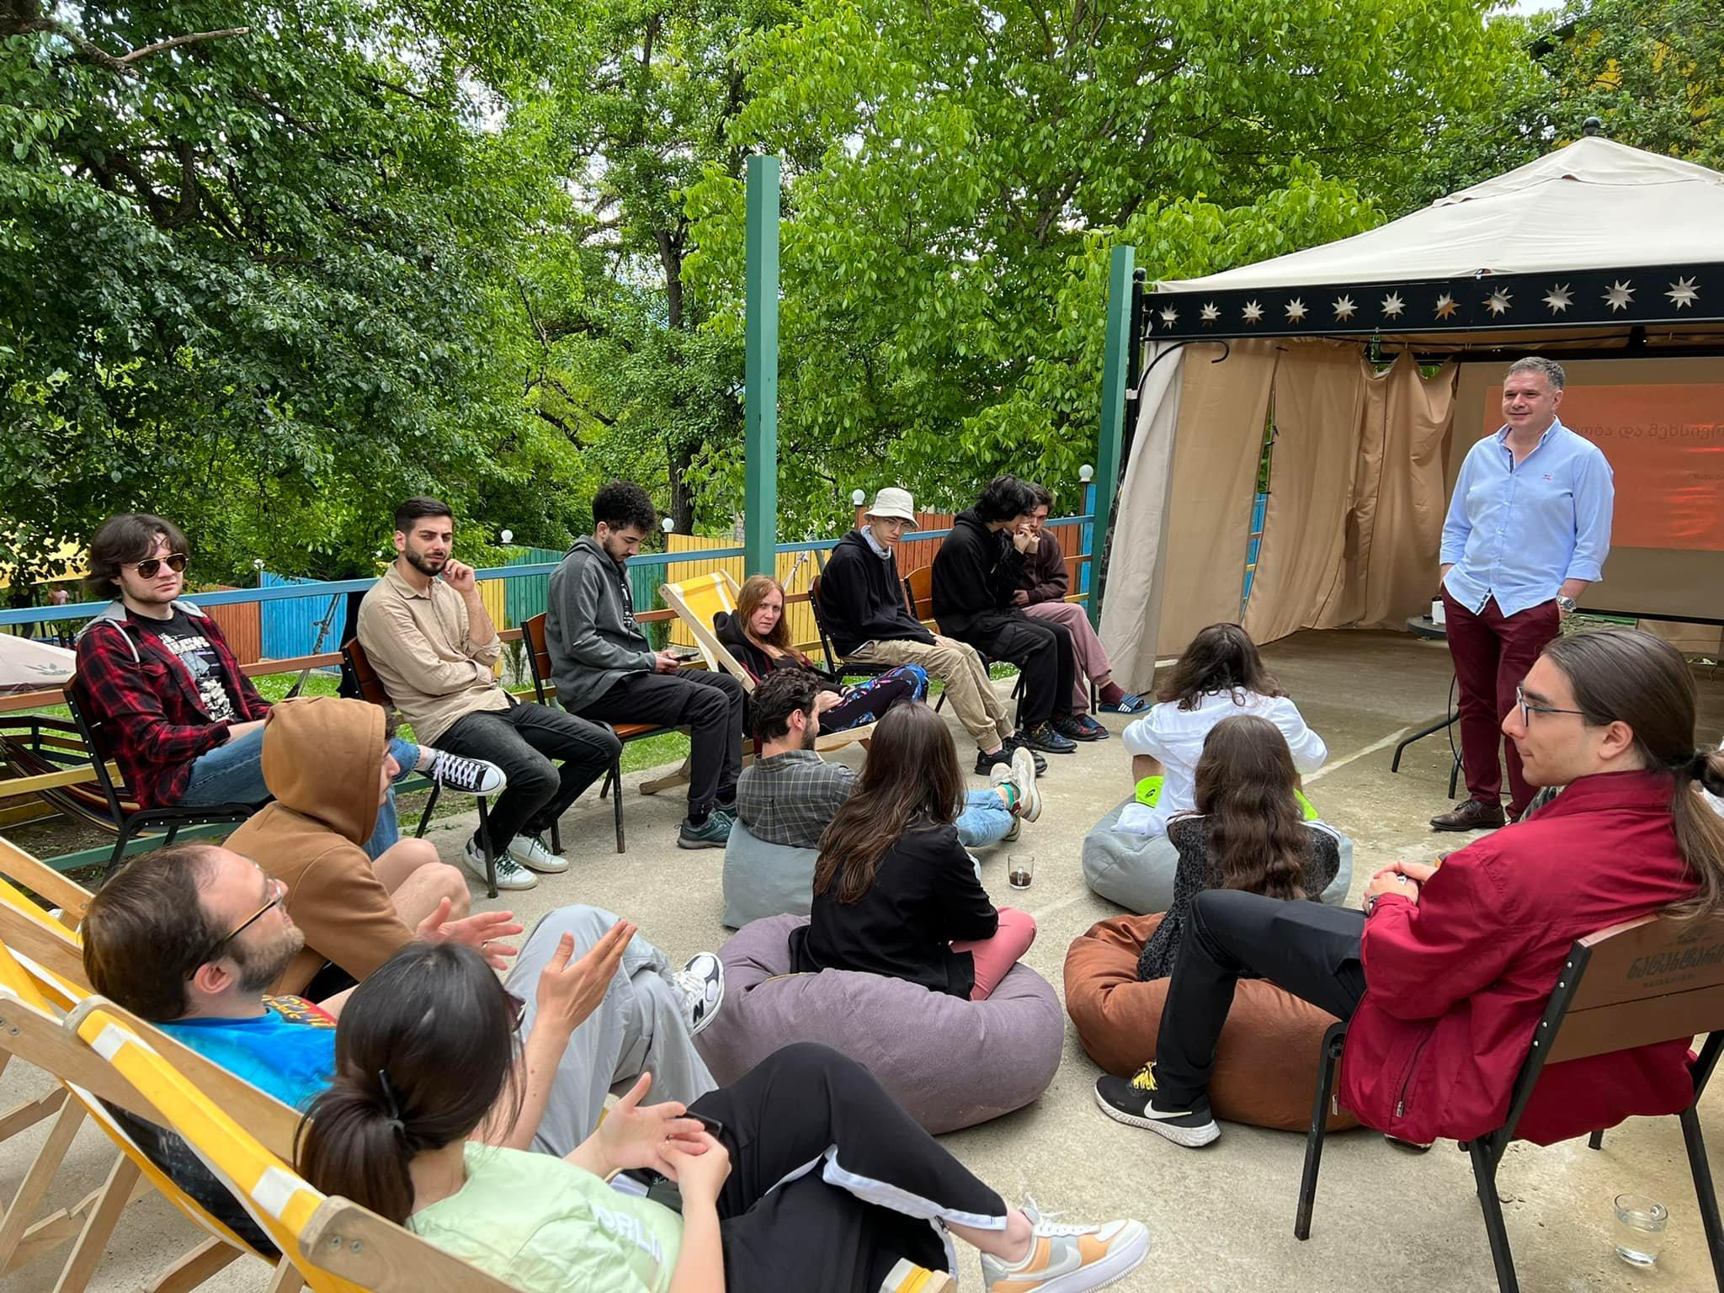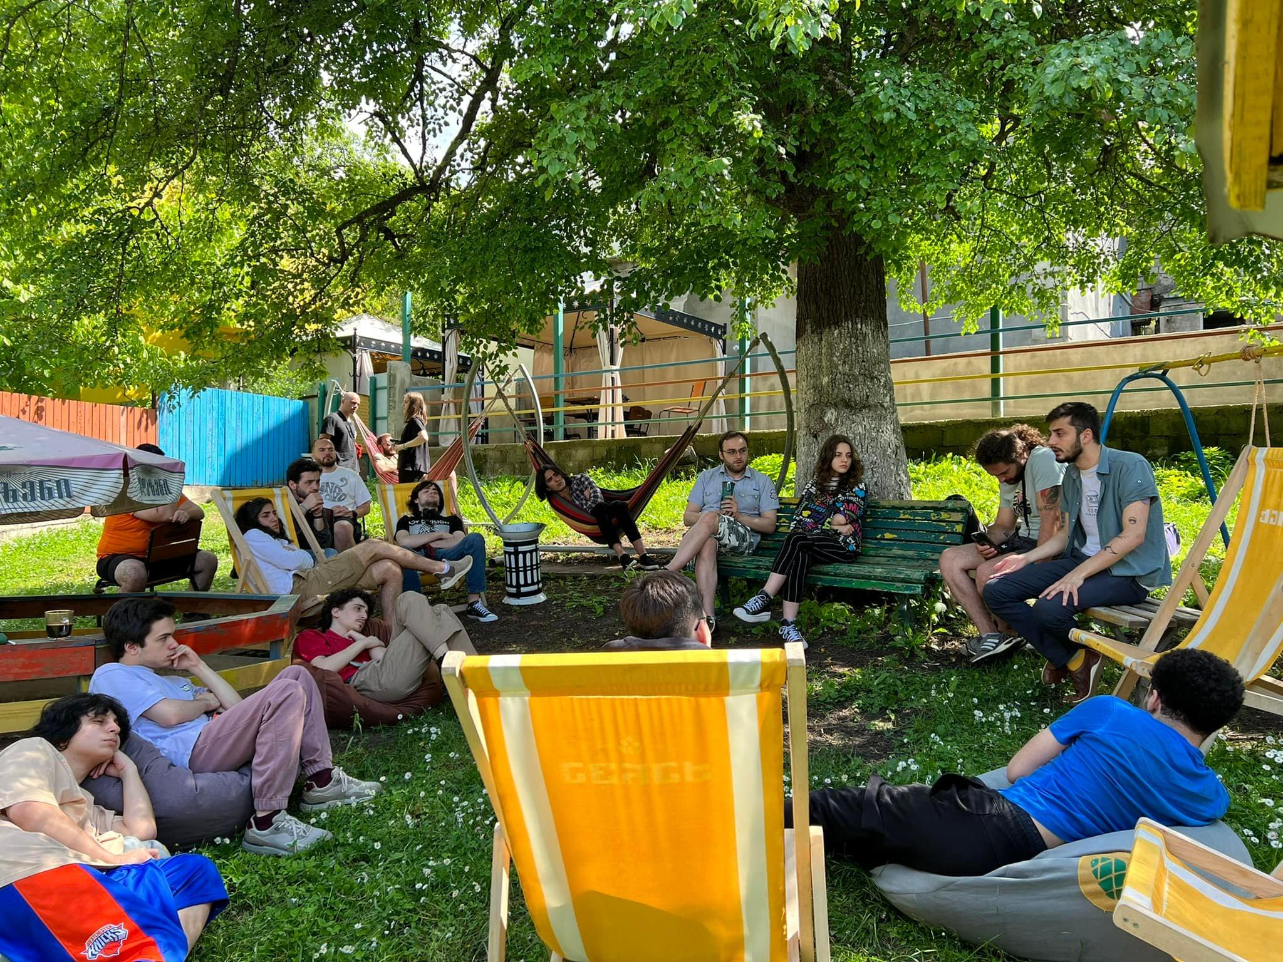

**Video**:<https://www.facebook.com/IFILiberty/videos/775537853813085>

**Liberty Weekend, Kobuleti**

The theme of the third camp was the European Union. The main focus of the camp was to familiarize participants with the history of EU economic development, Georgia's status as an EU candidate, and the 12 recommendations given by the EU. Camp activities included a discussion with MEP Marketta Gregorova, a hands-on course on army equipment, and a tour of a modern Coca-Cola bottling plant in Georgia.

**Invited Speakers and topics of the Camp:**

Zaza Bibilashvili - Founder of Chavchavadze Center - **“The art of Debate”**

Zurab Girchi Japaridze - Leader/Chairman of Girchi More Freedom - **“De Oligarchization”**

Boris Kurua - Politician of Girchi More Freedom - **“12 Recommendations Given by the EU”**

Marketa Gregorova - Member of the EU Parliament - **“EU candidate status, perspectives, and challenges”**

Levan Pkhakdze - TV show “Arms and Liberty” presenter - **“Practical Course of Weapons’’**

Marksman - Weapons System Trainer - **“Current Stories from Ukraine”**

Davit Rogava - Founder of Ayn Rand Center Georgia - **“The Ethics of Objectivism”**

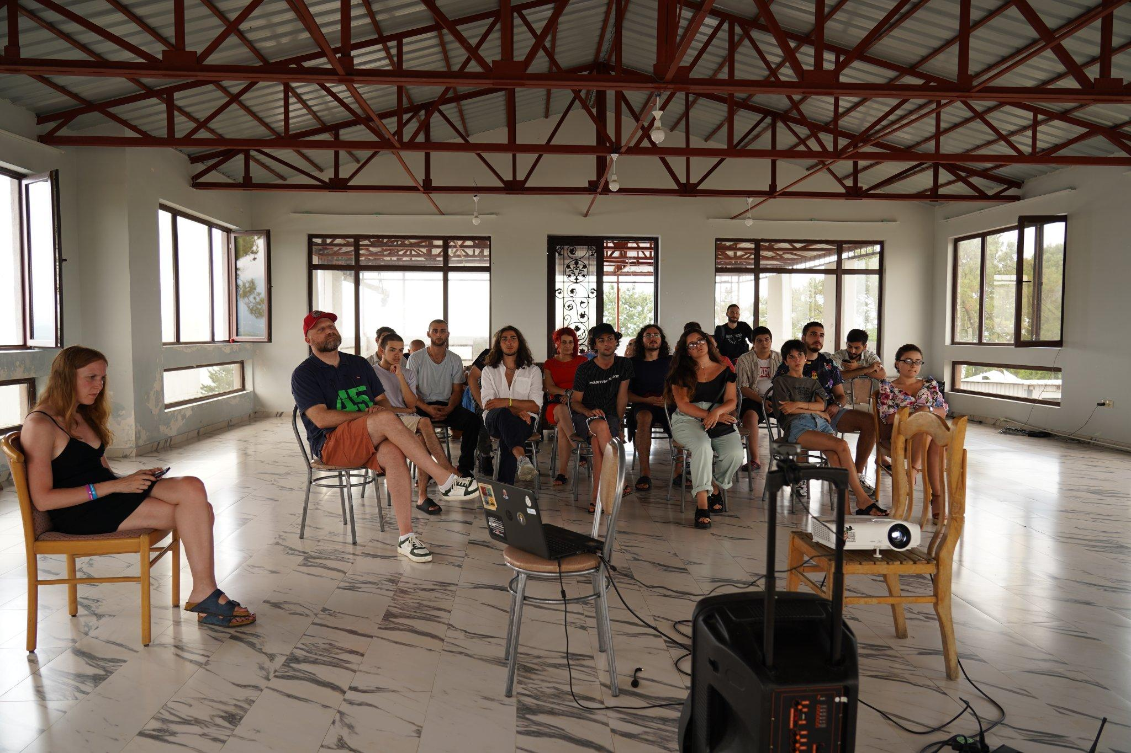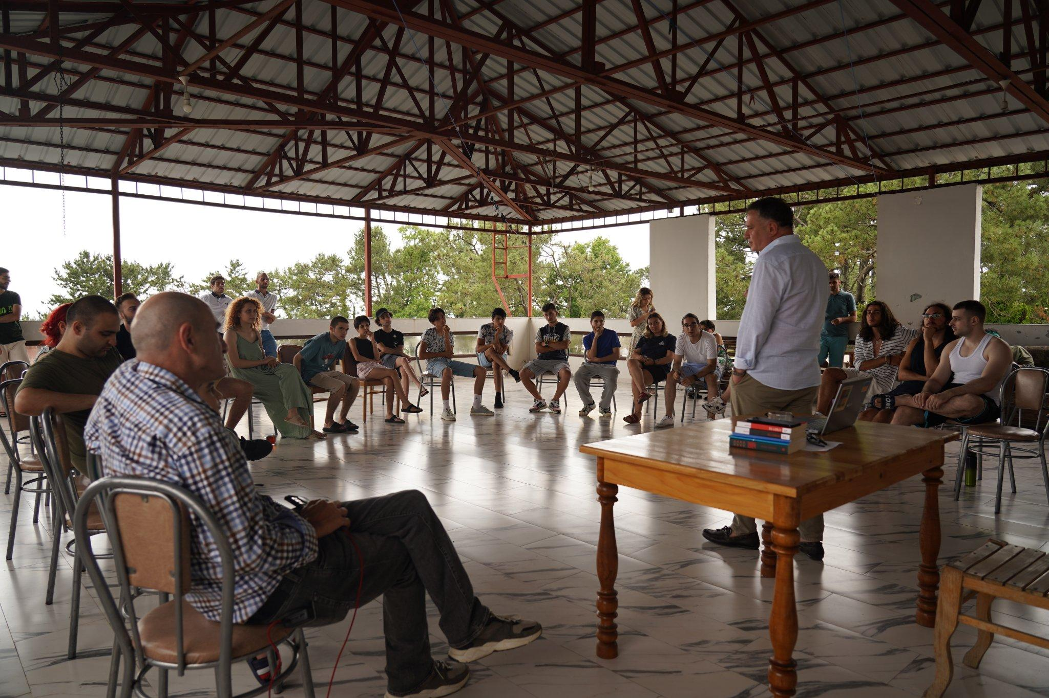

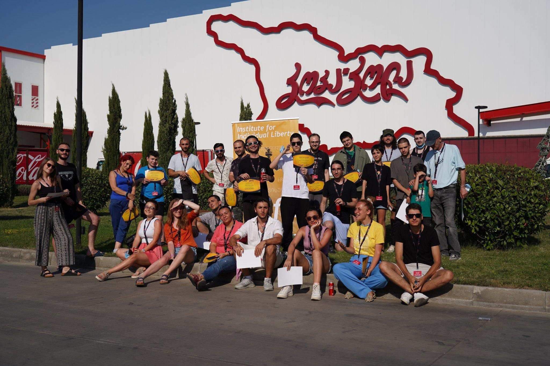

**Video:** [**https://www.facebook.com/IFILiberty/videos/373282171617814**](https://www.facebook.com/IFILiberty/videos/373282171617814)

**Who We Are:**

**Mirian Bezhitashvili - IFIL founder**

**Tinatin Bolokadze IFIL co-founder/ Liberty Weekend Project Manager**

**Ana Chikovani IFIL co-founder**

**Roko Mtskerashvili - Liberty Weekend Project Assistant/Financial Manager**

**Etuna Khaburzania - Liberty Weekend Social Media Manager**

**Giorgi Mosiashvili - Liberty Weekend Coordinator/Production team member**

**Revaz Buziashvili - Production team member**

**Email:** [**instituteforindividiualliberty@gmail.com**](mailto:instituteforindividiualliberty@gmail.com)

**Contact: +995 598 44 11 94**